**Task 5**

**Install Maven**

sudo apt install maven

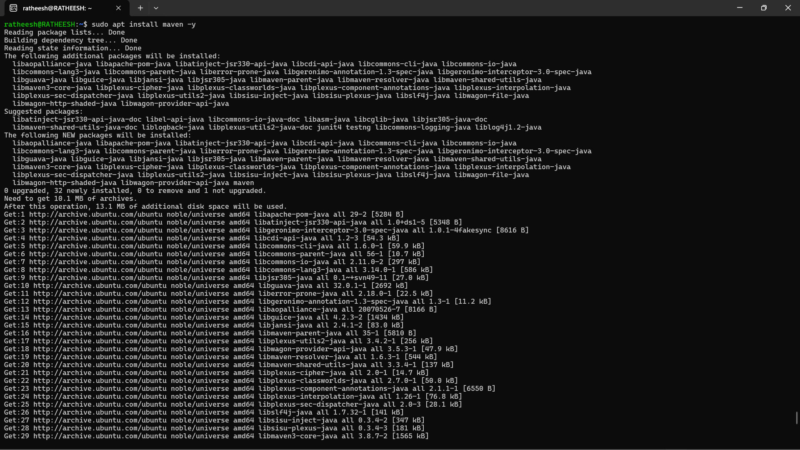

**Fork the repo on github**

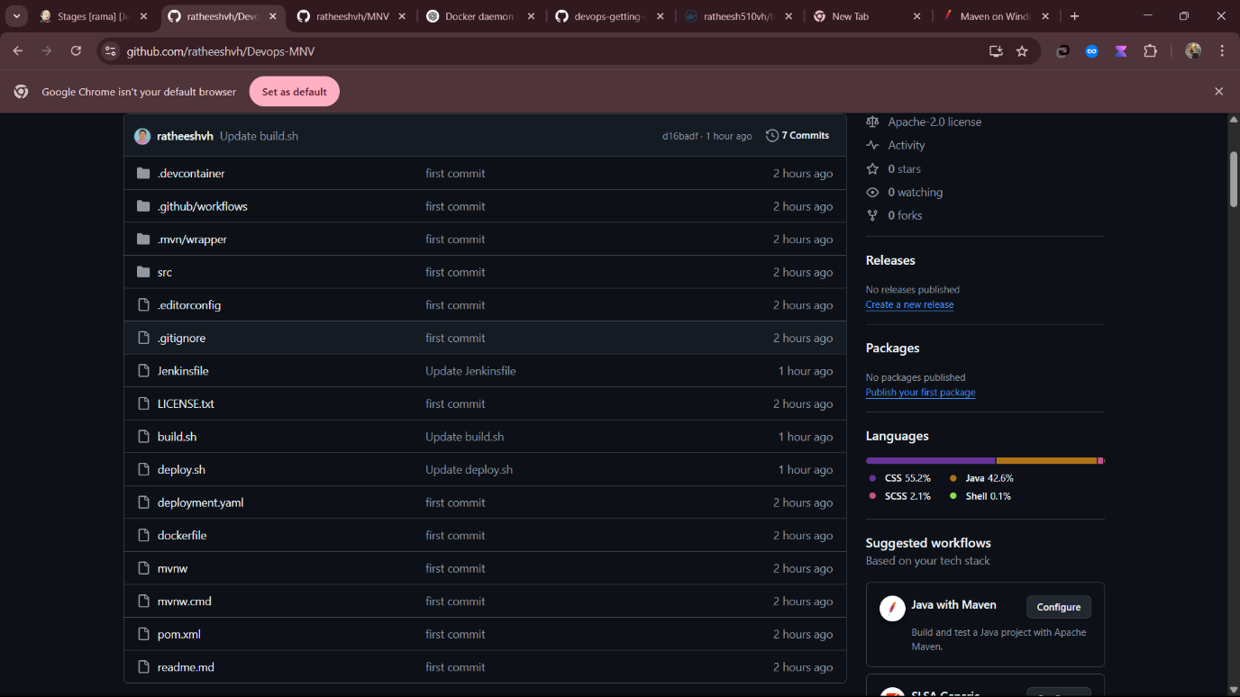

**Configure Jenkins**

* In Jenkins go to configure jenkins > tools
* Locate JDK section
* Uncheck Install Automatically
* Name Java 17
* Go to terminal and enter the command and get the java 17 path:

update-java-alternatives --list

* paste the java path in JAVA_HOME

